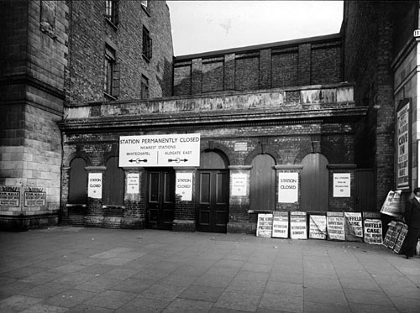

ST MARYS STATION WHITECHAPEL

St. Marys was a station that once stood on the District Line between Whitechapel and Aldgate East. Very little of this station now remains of, which some can be seen inside the tunnel.